**Create_Table_and_Insert_Values.py**

**Output of Creating Table and Inserting Values in it:**

**(On Python Idle)**

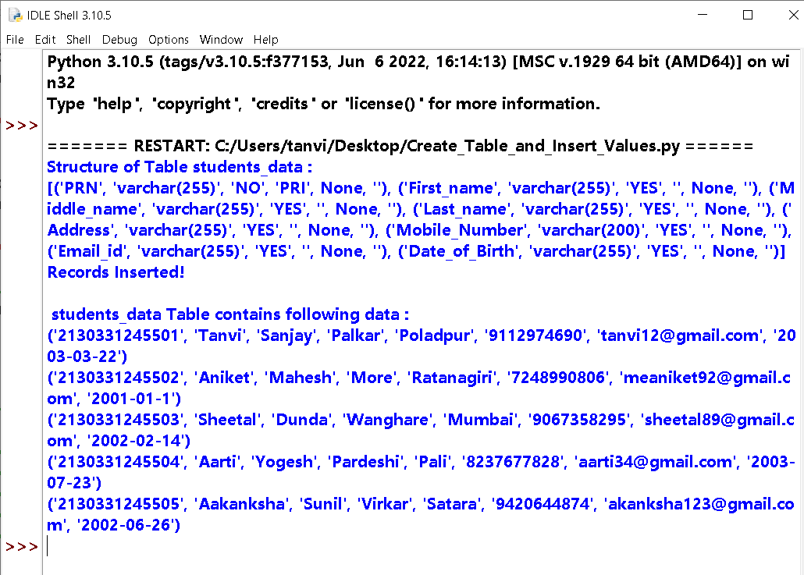

**Output on mysql console:**

